Unity3d ultimate social share plugin for Android and iOS

**1. Description**

This plugin allows you to use the native sharing window of your mobile device.

* Works on Unity3d 5.0+
* Works on Android, version 2.3.3 and higher (probably 2.2 as well).
* Works on iOS6 and up.

## 2. Screenshots

iOS 7 (iPhone)

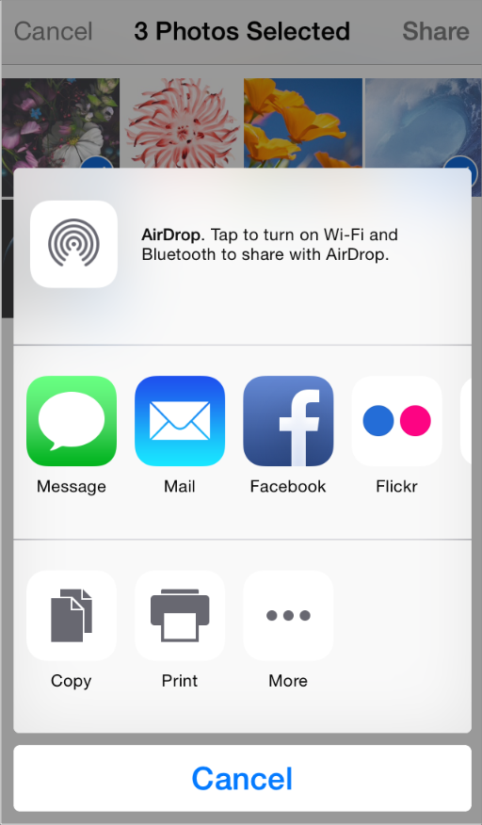

Sharing options are based on what has been setup in the device settings

Android

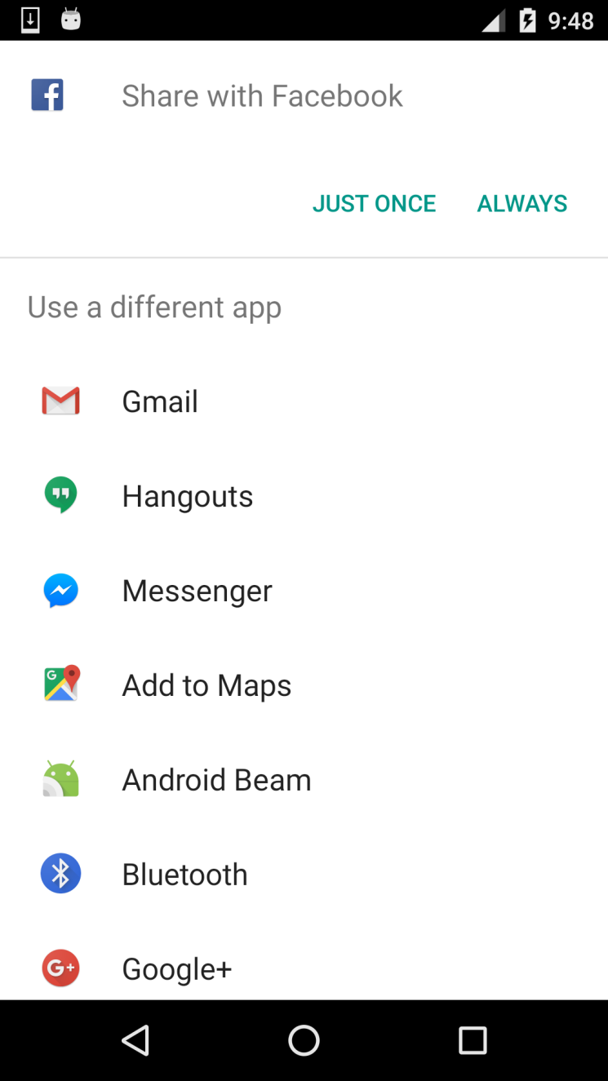

## 3. Usage on iOS and Android

using UnityEngine;  
using System.Collections;  
  
namespace jtac.SocialSharing  
{  
    public class Example : MonoBehaviour  
    {  
        [SerializeField]  
        private SocialSharing socialSharing;  
        [SerializeField]  
        private string text;  
        [SerializeField]  
        private Texture2D texture2D;  
  
        public void Click()  
        {  
            *//Share text+screenshot*  
            socialSharing.ShareScreenshot(text);  
  
            *//Share text+texture2D*  
            socialSharing.ShareTexture2D(text, texture2D);  
        }  
    }  
}